Management Education
Prescriptive approach to management education leads to diminishing value from education with passage of time. Education should stimulate and catalyse disruptive and exploratory thinking to sync with the dynamic environment. Education should train people to think, analyse, recognise and draw meaning from visible and hidden patterns, innovate and experiment. A prescriptive approach implies past works for the present and will work for the future that may be unrealistic.
- Evolution of management theories
A chronological examination of management theories and concepts reveals that, the theories are a distilled and formal narration of practices adopted / attempted to bring about a scientific (inquiry based) approach to management of primarily manufacturing enterprises as illustrated below.

- Henri Fayol’s (1841-1925) Classical management school identifies the principles and skills underlying effective management under “14-principles of Management”. These encompass the most mundane prerequisites such as

- Physical:(health, vigor)
- Mental: ability to understand, learn, judge,)
- Moral: (energy, initiative, loyalty, dignity)
- Educational: (knowledge management)
- Technical: (specialist)
- Experience
to requirements for orderly organisational functioning such as
- Division of work
- Authority and responsibility
- Discipline
- Unity of command
- Unity of direction
- Subordination of individual to general interest
- Remuneration of personnel
- Centralization
- Scalar chain
- Order
- Equity
- Stability of tenure
- Initiative and team work

- Measurement of work, worker productivity, deployment right kin ad right measure of manpower assessed through granular study of worker’s handling tasks (time and motion study), appropriateness of skill and harmonious labor management relations (Frederick W. Taylor (1856-1915))

- Management’s task of scheduling production using “Gantt Charts” for efficient accomplishment of complex tasks (Henry L. Gantt (1861-1919))

- Recognising need for attention to workers’ welfare through fatigue & motion studies, (Frank Gilbreth ( 1868-1924) & Lillian Gilbreth (1878-1972))

- Workers recognized as partners in prosperity through “Profit Sharing System” for workers (Charles Babbage (1932) )

- Moving towards formalisation of organizational functioning through levels and reportng systems - Bureaucracy (Max Weber) for large organisations adopted by GE, Xerox

- Recognising the emotional needs of workers by Elton Mayo revealed through (The Hawthorne Experiment), a shift from mechanist to a social approach to worker management, a blow to failure of scientific management

- Peter Drucker era on Management that focused on outputs, outcomes and measurement of management functions, accountability of organisations to stakeholders, principles of organizing using activity, decision and relation analysis, federalism, Management by objectives et al

Management was seen through three fundamental different approaches:
- Mathematical: quantitative, rational, analysis,
- Human behavior approach: meeting people’s emotional and rational needs, recognizing behavioral trends, motivation

- Systems Approach: recognizing complexity and interconnectedness in management, holism, multiple external and internal influences on outcomes, Management as a social system, Management as open system, Adaptive, Dynamic, Probabilistic and Multilevel and multidimensional. The Mc Kinsey 7 S Model is a formal recognition of this systemic nature of management

- Contingency or situational approach: actions and outcomes are situation dependent and cannot be prescribed as true for all scenarios
- Management as tool
Management was largely seen as a tool to improve efficiency and productivity of tasks undertaken largely with human labour, in manufacturing, during the initial phases of the industrial revolution, to generate more and faster out of human resources deployed for production to meet demand and withstand competition. The task was how do I make my products cheaper and faster delivery for the consumers. Mass production, mechanisation and automation followed supported by new possibilities from technological innovations. The profile of human labour shifted from unskilled to semi-skilled and progressively skilled; and management realised the need for recognising value of contribution from human knowledge and skill, and not limit rewards to how hard their muscles were put to use.
Management theories graduated to means of motivating workers and supervisors to work in teams, bring their knowledge to the workplace and make them active contributors to achieving management’s objectives. Theories of organisation structure, autonomy, working in teams, roles and responsibilities, output and productivity measurement, performance incentives recognising contribution from human capital and making employees partners in prosperity followed.
- Shifting paradigms
Relative contribution from agriculture, manufacturing and services to GDP underwent major shifts in the last century; conspicuously the swapping of contribution from manufacturing and services; manufacturing giving way to services. This transition has driven fundamental shifts in management theories and practices.
Dramatic shift from agriculture to services
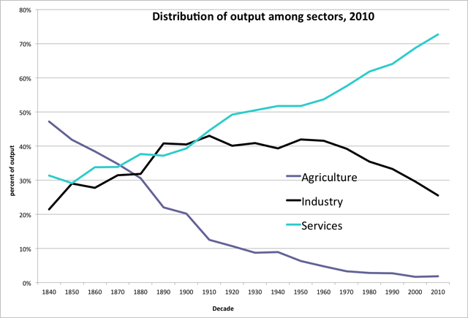
Source: http://www.minnpost.com/macro-micro-minnesota/2012/02/history-lessons-understanding-decline-manufacturing

Agriculture that contributed about 48% of GDP in 1840 dropped to about 3% in 2010 and services that contributed to about 32% jumped to 73%. Industry contributed to about 20% with a marginal increase of about 1.5% during the period with a U shaped behaviour
Employment shift
In the private sector, services gained 30% from the goods sector, during 1948 to 2010 in line with private sector output as seen below.

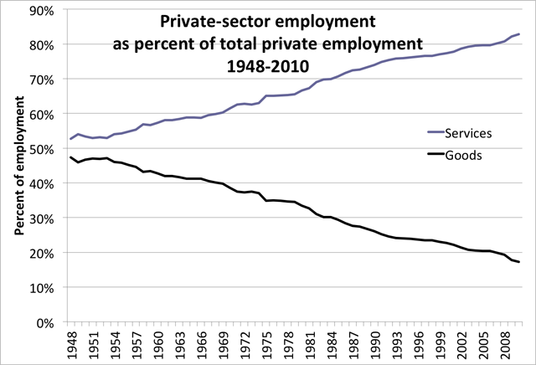
Source: http://www.minnpost.com/macro-micro-minnesota/2012/02/history-lessons-understanding-decline-manufacturing

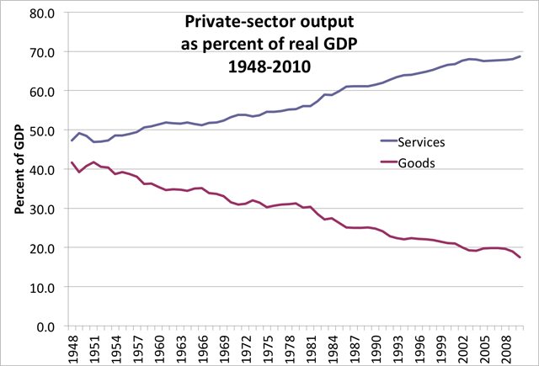
Source: Bureau of Economic Analysis, National Income and Product Accounts
- Shifts in HR Management
Labour; one of the three (land, labour and capital) means of production is now recognised as Human Capital. Supervision has given way to empowerment and autonomy. Training cost is now investment in human capital. Penalties and punishments have given way to motivation, total employee care, concepts of employee as shareholder, variable pay and performance incentives, rewards in the form of ownership and employees as autonomous growth partners, policing to trust and independent working, performance measured in the form of efforts (no. of hours of work) to performance measured in terms of tangible outputs.
- Quality control
Shifts in nature of businesses and management practices have transformed the way quality is defined and measured. In manufacturing, the product is manufactured, quality is monitored, measured and ensured before delivery of product to the consumer. In the service industry, production and delivery are co-terminus. Production and delivered is by the creator directly and instantaneously to the customer without any quality check. Quality check is replaced by quality monitoring as feedback from the customer after its delivery. Customer decides the quality and not the management.
Quality delivery is only enabled through systems and processes that are expected to lead to quality service delivery. High reliance and dependence is placed on the service producer for quality (self-certification?). The producer is a key element in the chain.
- Power shift to producer (worker)
With the onus for quality on the producer (worker), the producer need to be adequately trained, motivated and compensated and less supervised. The worker knows the end customer more than the management, de-facto fact assuming responsibility delivery. Workers are knowledge workers (several levels above even skilled workers): with differing expectations, at higher levels in Maslow’s hierarchy of needs. Worker expects recognition, respect, autonomy, opportunity, competency up-gradation, with monetary benefits being only one among the list of expectations, placing complex demands on HR management. Worker being self-managed has led to flat organisational structures and worker participating in decision making. Even the terminology worker (employee) is rechristened as associate to reflect his changing role, perception and recognition. In this scenario, old tenets of organisational structures, organising, controls will need a metamorphosis.
- Disintermediation
Emerging practices enabled by information technology is leading towards a kind of disintermediation, possibly leading to irrelevance of the conventional business organisation, catalysed by crowd sourcing and granular business relationships from direct link between customer and provider of services. Evidence of this trend are several freelancer sites, that provide the market place linking producer and consumer. Such models demolish the power of large business houses with deep pockets for market reach; the virtual market place platform creating a near equality of all providers without differentiation between a mom and pop shop and a global conglomerate providing similar goods / services. The virtual platforms also lead to higher levels of democratisation: equal opportunity to all.
The contours of competition space is redrawn, with even large corporates following the mom and pop shop trends to not miss out on micro opportunities. This trend will catalyse consumerism and entrepreneurship without constraints of legacy, brand value, physical reach, marketing budgets and long gestation periods. Corporations have started to read the writing on the wall: recognising power in the hands of entrepreneurs; and even their own competent employees encouraged into entrepreneurship for relationships as business partners and not as employees.
Manager should be able to sense these are paradigm shifts creeping in and their potential impact to own business and counter measures to guard one’s turf or even exploit the new opportunity. The big business now is not making and selling, but are platform providers who never make, stock or even see the goods that traverse their space, but only enable the meeting and transaction. Enablers of business transaction with innovative value additions become the new power centres and not the ones with deep pockets for capital investment in P&M, distribution set ups, inventory, marketing and so on. This power shift brings about new models of management.
- Business valuations
Investment feasibility used to be based on principles of IRR, NPV and Pay-back period. The new trend appears to be betting on invisible (imaginary) revenue and profit streams expected to be derived from access to (control over) user / customer base. Data on online transaction user base become the key strength. Business valuations based on customer data base are betting on ability to monetise this data base, a second level derivative. Are we moving towards another sub-prime lending bubble?
Are we moving from rational to intuitive decision making due to poor visibility into the future possibilities except a qualitative expectation? How does one justify such decisions (gambling?) to share-holders without convincing supporting data? How confident and comfortable will the decision makers be when confronted with such situations? And what would be their accountability?

- Business strategy
Business strategy revolved around identifying opportunities for revenue generation from expansion, diversification, new opportunities, managing competition.. The meaning of strategy has taken a new turn, to mean, actions to identify asset creation for long term monopolistic (developing sticky relationships) revenue opportunities. Asset creation meaning; monopolistic access to markets for inputs and products / services: acquiring businesses for building base for potential sustainable e-commerce revenue, access to mineral resources for sustainable long term supply, access to monopolistic technology for conversion into valued goods and services. Businesses look at global sources for strategic control through ownership and rights, even control through open (statements of intent only) collaborations.
What management education should aim at is developing skills for gaining insights, visibility beyond the obvious, strategically developing competitive positions through innovative means (monopolistic markets for long term supply to continued use of technical systems, machinery, technical services,..), creating competitive advantage through trade blocks and building dependency through contracts, power …. Ability to see / create invisible competitive opportunities will mark the new generation manager.
One of the drivers of market opportunities used to be population growth and GDP growth translated into buying power. This has now translated into gaining granular visibility into shifting composition of demography and markets in each potential market, ratio of productive and dependent population: large proportion of aged / young population offering unique opportunities and constraints.
- Aspiration selling
Markets are no longer driven by need to meet basic human needs of food, clothing and shelter but by creation of new business opportunities by pumping up aspirations and meeting those aspirations of the higher echelons of society. Aspirations are unwanted needs and may not be apparent, but enterprising businesses pump up aspirations that get converted into needs and markets. Eg. include several personal care products, luxury goods, fashion goods, holiday and leisure travel services, space tourism, body building, grooming and appearance management, entertainment, event management, high end cars and homes,…. These are truly creative building around a theme, developing products and marketing to those who don’t need but aspire for these. Conventional theories on market / demand / competition analysis, demand estimation, etc. don’t work, as there is no base to work from, as these are absolutely non-existent and are products of imagination and creation.
Management training should emphasise on creative thinking orchestrating multiple elements, in a manner to create competitive barriers and carve a monopolistic turf for one self.

- Global Perspective
Businesses have crossed all national boundaries due to geopolitical changes, shifts in demand scenario, demographic factors, globalisation driven by technology, cross border competitive advantages, compulsions / opportunities for access to competitive resources, global trade and economic policy agreements, varying regulatory constraints and advantages… A holistic assessment capability is the key vis a vis a single track analytical mind. Synthesis of multiple elements is as important as analytical wizardry. How do we train managers to handle complexity? No one formula will deliver a solution, but an appreciation of the complexity, the dependencies / interconnectedness and judicious orchestration will do. The key is integration of multiple elements to make the whole work in a sustainable manner. This needs skills in putting the pieces of the puzzle together, making meaning out of it, effectively communicating and convincing and delivery skills. The key word is orchestration, not a mechanical application of prescribed tools.
- Political management
With blurring lines between politics and businesses, managers need to be adept at the art of political selling and diplomacy. There is no one right way that one can learn from a guru, but only sensitivity to the complexity and how one can derive maximum value from it.
Many innovations touch all sections of the society: for instance Internet, Computers and Telecommuncations (ICT). When large and multiple constituencies are involved, it is natural for political attention. The driving factors are not competition in the market place, but competition for a favourable mind space of the political decision maker. Are MBAs trained on the nuances of political management?
One of the emerging considerations is multi stakeholder management to gain acceptance. Managers need to be sensitive to what may not appear logical from a businessman’s perspective to get large constituency buy in, without which the initiatives will derail.
Sensitivity to cross border legalities while operating in multiple geographies. Cross border operations come with tangible gain opportunities as well as risks. Manager’s ability to sense these will determine the outcome of their efforts.

